Implementation Summary
Macroinvertebrate Image Analysis System

1. Project titles and group members

Items | Details
Project | Macroinvertebrate Image Analysis System
Member 1 | u3327375
Member 2 | u3330354
Member 3 | u3334444
Unit | Software Technology 1 (4483)

2. Project Goal

The purpose of this project was to develop a Python application capable of analysing and classifying
freshwater macroinvertebrate images. The system processes a dataset containing 2,665 images
across 17 species and applies machine learning techniques to identify species classifications

3. System Design Overview

The application was developed using a modular software design approach. Dataset indexing,
exploratory data analysis (EDA), preprocessing, classification, and workflow coordination were
separated into different classes and modules. This structure improved readability, organisation,
testing, and maintainability

4. Class and Module Overview

Class | File | Responsibility
Dataset indexer | dataset_indexer.py | Scans all species folders and loads the image information into a Pandas DataFrame.
EDAService | eda_service.py | Generates charts including class  distribution, image sizes, and sample image grids.
ImagePreprocessor | image_preprocessor.py | Converts images to grayscale, resizes images to 128x128 pixels, and flattens arrays
ClassifierService | classifier_service.py | Trains and evaluates the Random Forest classification model and saves the results.
WorkflowService | workflow_service.py | Coordinates the overall system workflow  and executes the pipeline.
ImageRecord | records.py | Stores metadata related to each image using a dataclass structure.

5. Tools and Libraries used

Library | Purpose
Pandas | Stores image information in structured DataFrame tables
NumPy | Handles numerical arrays and feature processing.
OpenCV | Reads and preprocesses image files.
Matplotlib | Creates graphs, charts, and confusion matrices.
SeaBorn | Provides chart styling and heatmaps.
Scikit-learn | Supports model training, testing, and evaluation.
Joblib | Saves and loads trained machine learning models.
Pathlib | Handles file and folder path management.

6. Key feature Implemented

Stage 1 — Exploratory Data Analysis (EDA)

- Loaded and indexed 2,665 images from 17 species folders.

- Generated class distribution charts.

- Generated image size distribution charts.

- Generated sample image grids.

- Displayed dataset summaries.

Stage 2 — Classification and Evaluation

- Preprocessed images into grayscale 128x128 pixel arrays.

- Split the dataset into 80% for training and 20% for testing.

- Trained a Random Forest classifier with 200 estimators.

- Achieved 71.1% classification accuracy across 533 test images.

- Generated confusion matrices and classification reports.

- Provided an interactive species selection menu.

7. Testing summary

Scenario | Expected result | Actual result
Run main.py with the full dataset | Loads 2,665 images | Passed
Generate EDA charts | Charts saved successfully | Passed
Train model | Achieves classification accuracy | Passed
Select species from the menu | Displays species details | Passed
Invalid menu input | Displays validation message | Passed

8. Sample outputs

i) Loading dataset
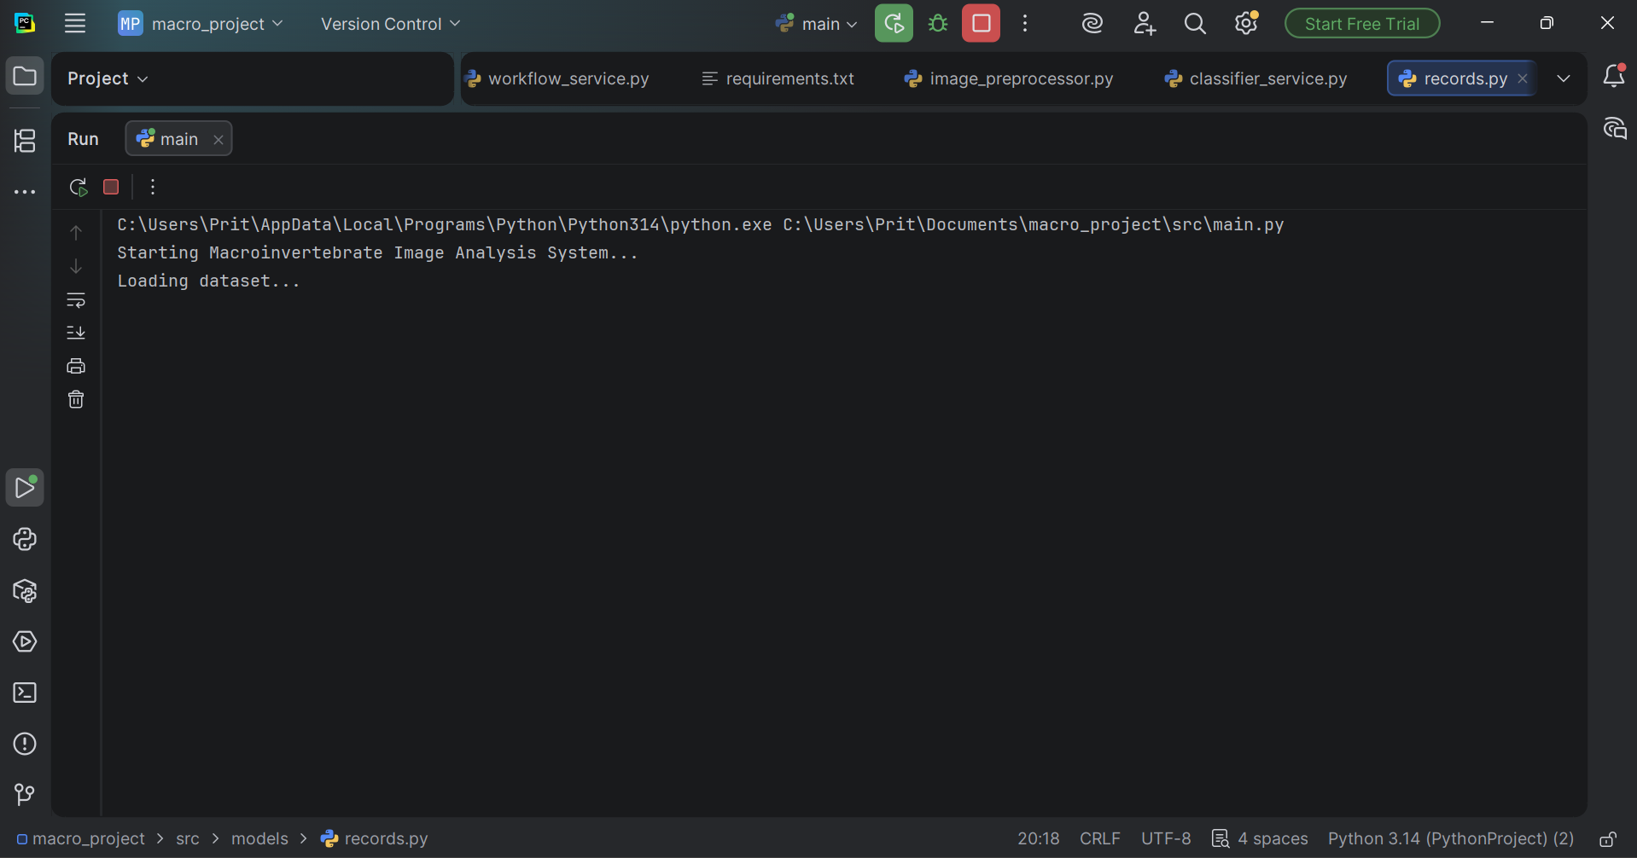

ii) Dataset Summary 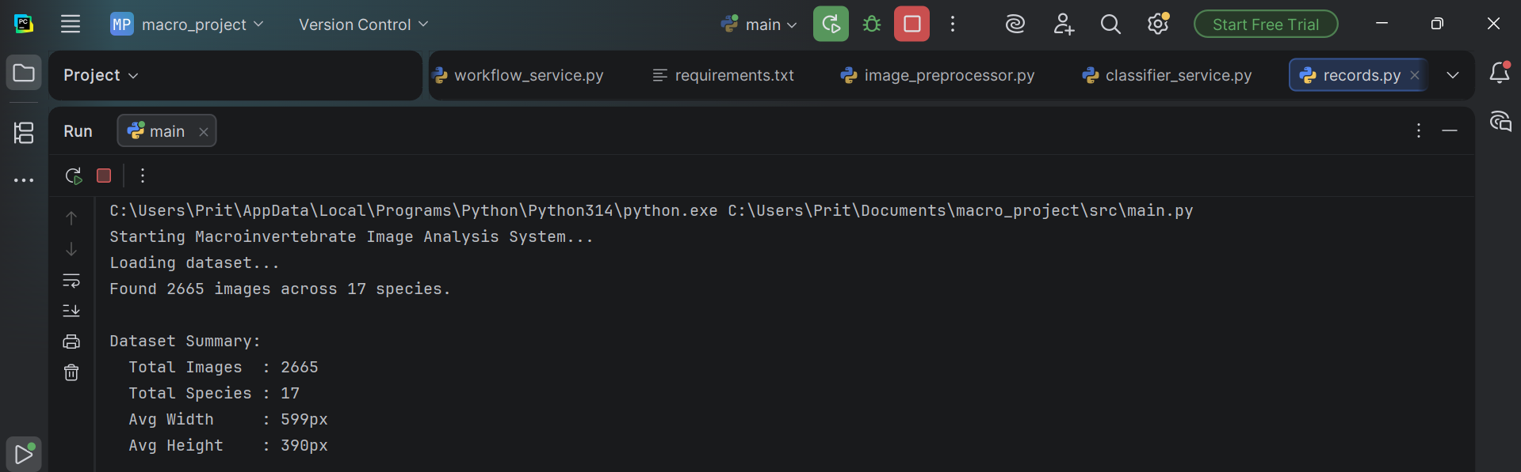

iii) Generating EDA charts 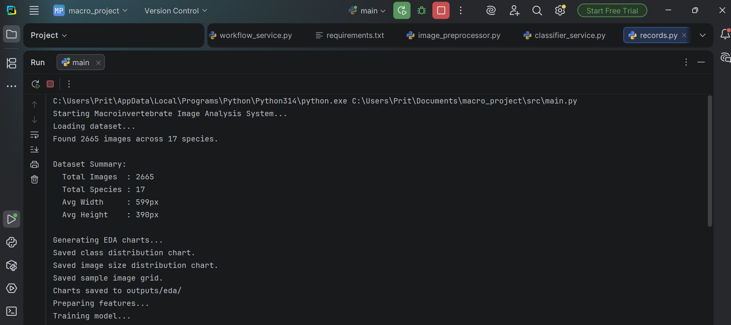
Results:
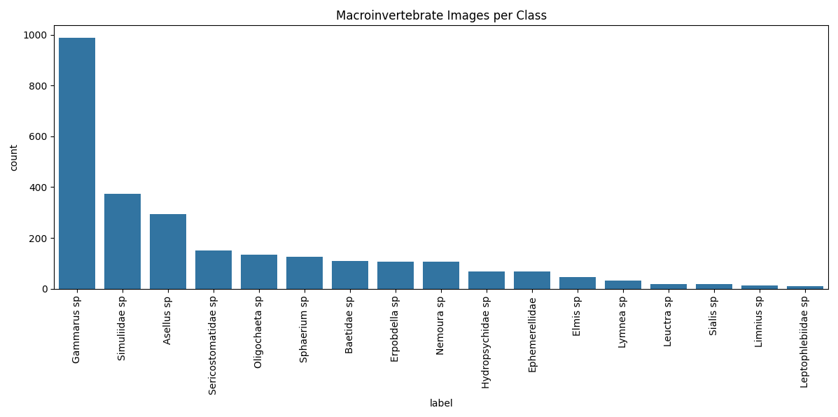

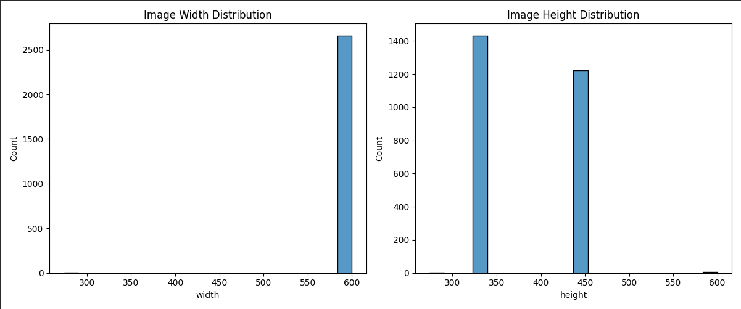

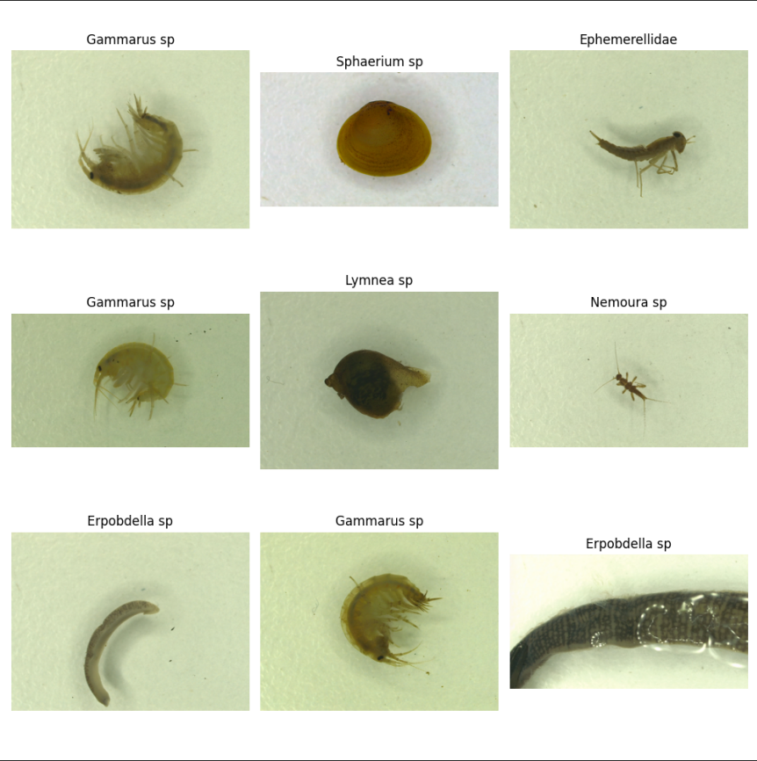
iv) Train model

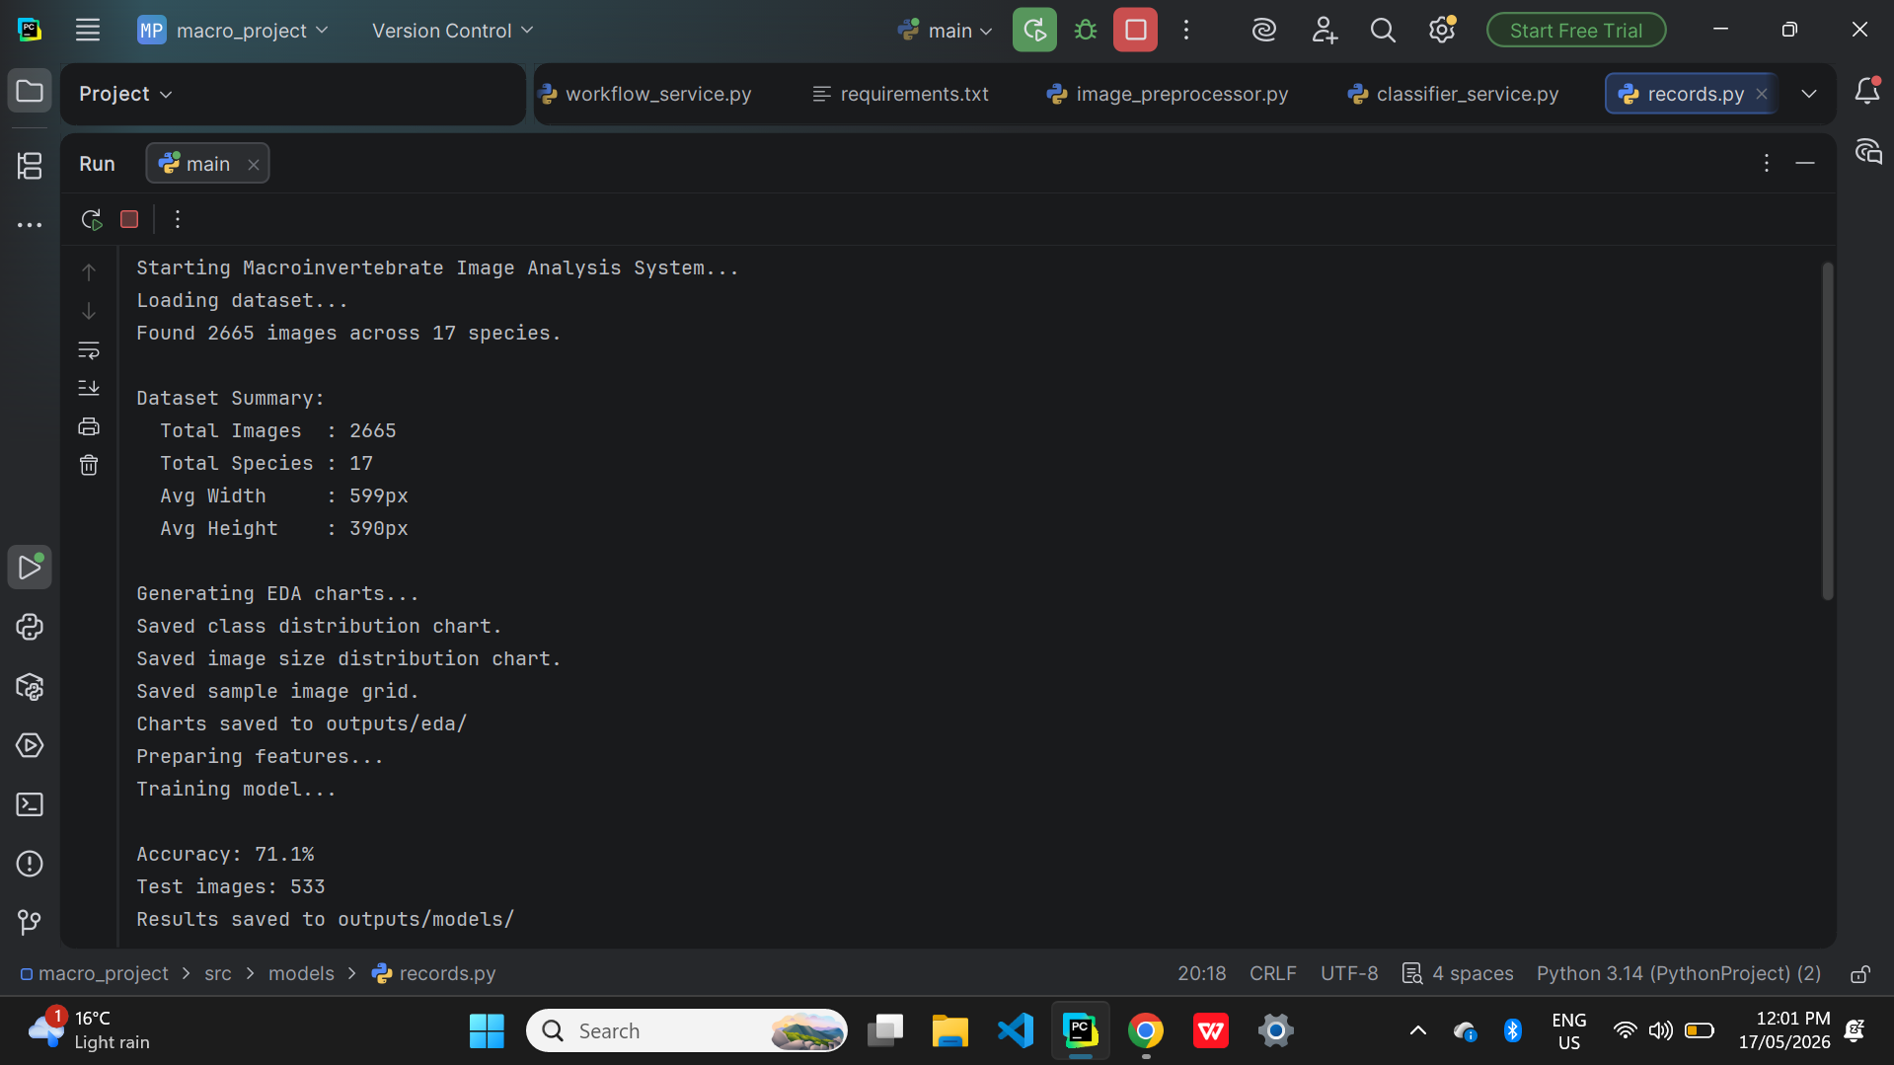

Results:
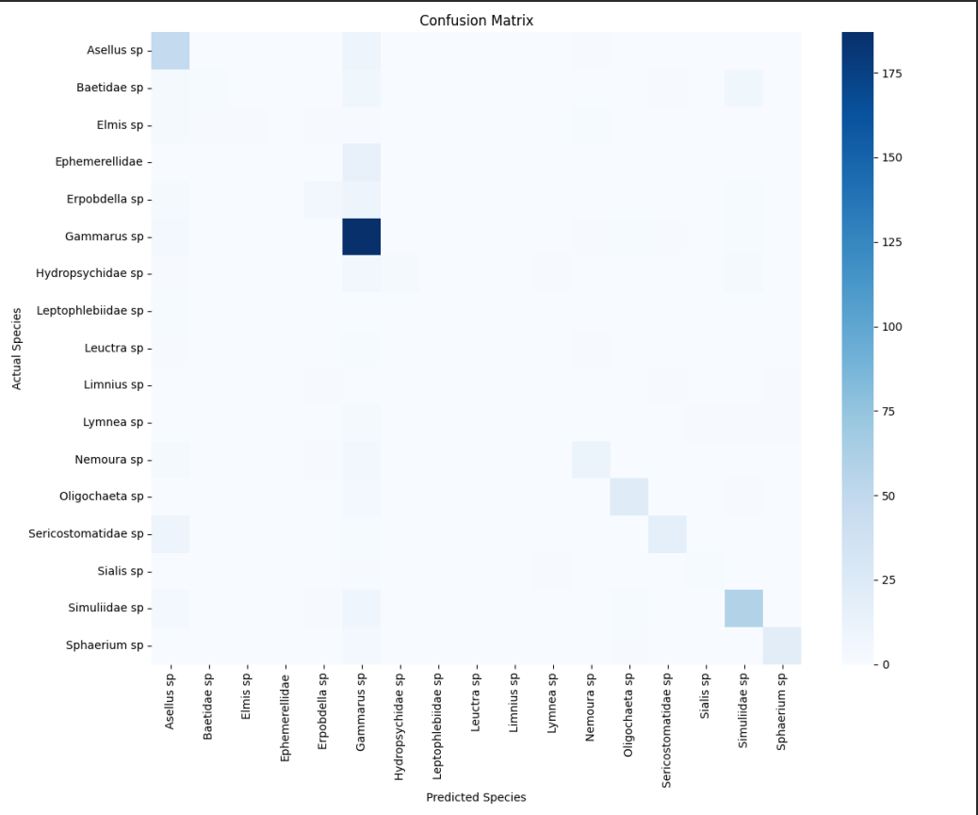

v) Select species from the menu

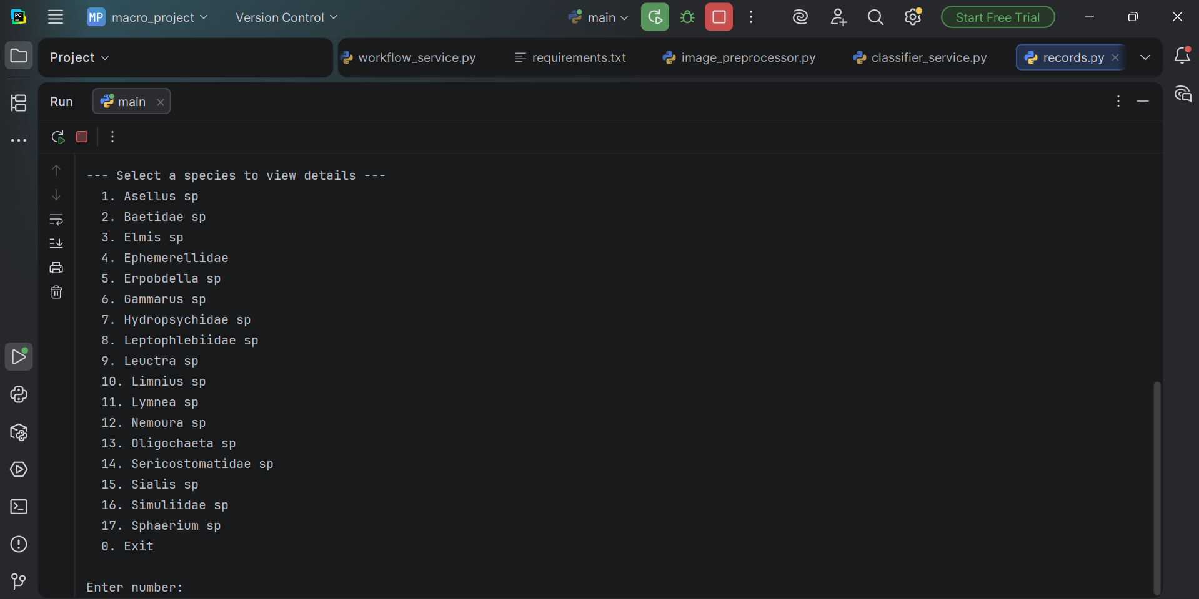

9. Acknowledge code

Some implementation patterns and design structures were informed by guidance materials provided within the unit. All code was modified and adapted to suit the specific requirements of this project.

